This was an optional meeting

Attended:

Anthony, Alex L, Jairo G, Tony N

Missed:

Alex B

Responded well to status follow up

Joe

Responded well to status follow up

**Meeting Body**

* Class diagram review -- Tony
* Class diagram drawn on board -- Alex L
  + **MVC whole board**
    - 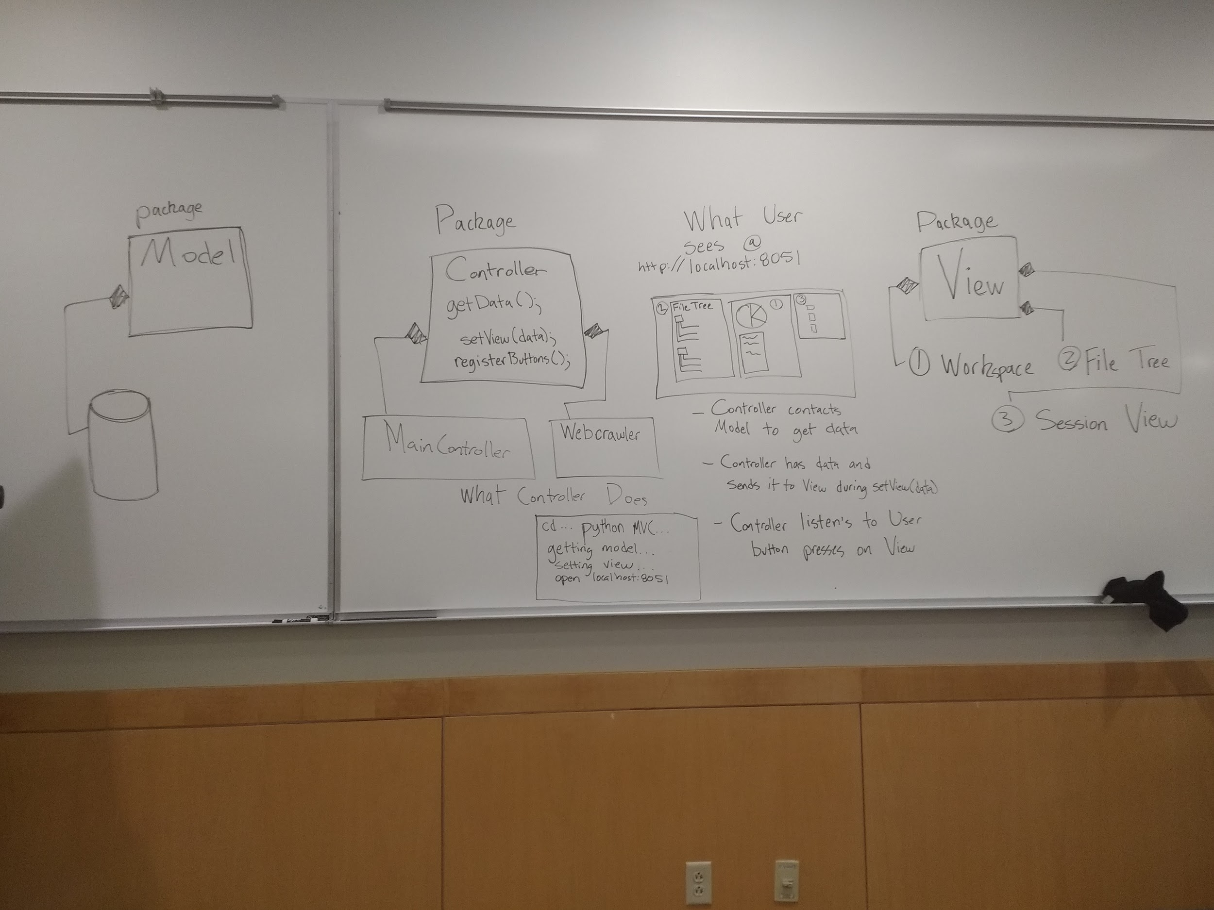
  + **Controller**
    - 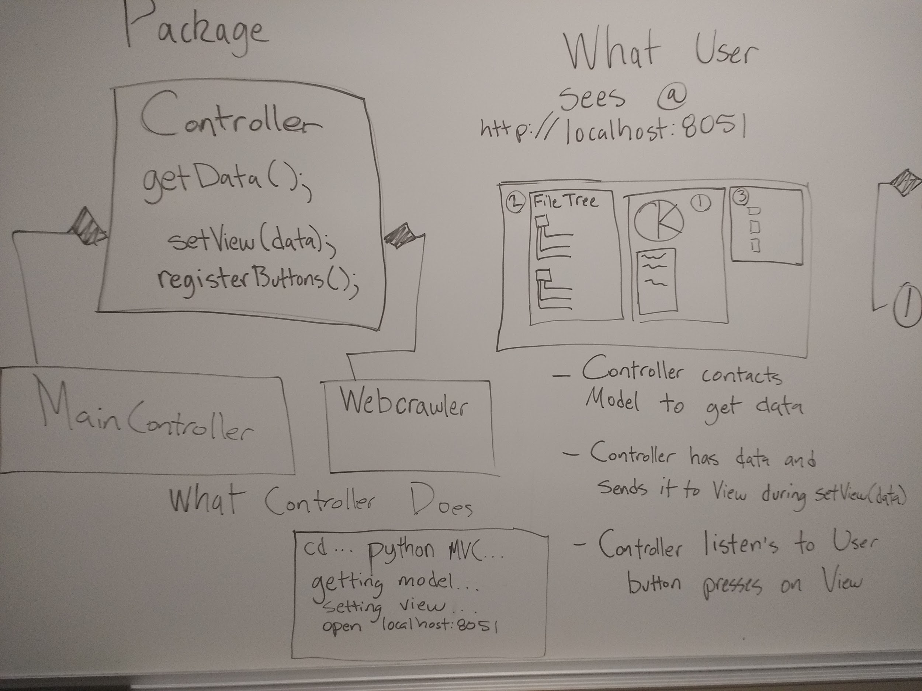
  + **View**
    - 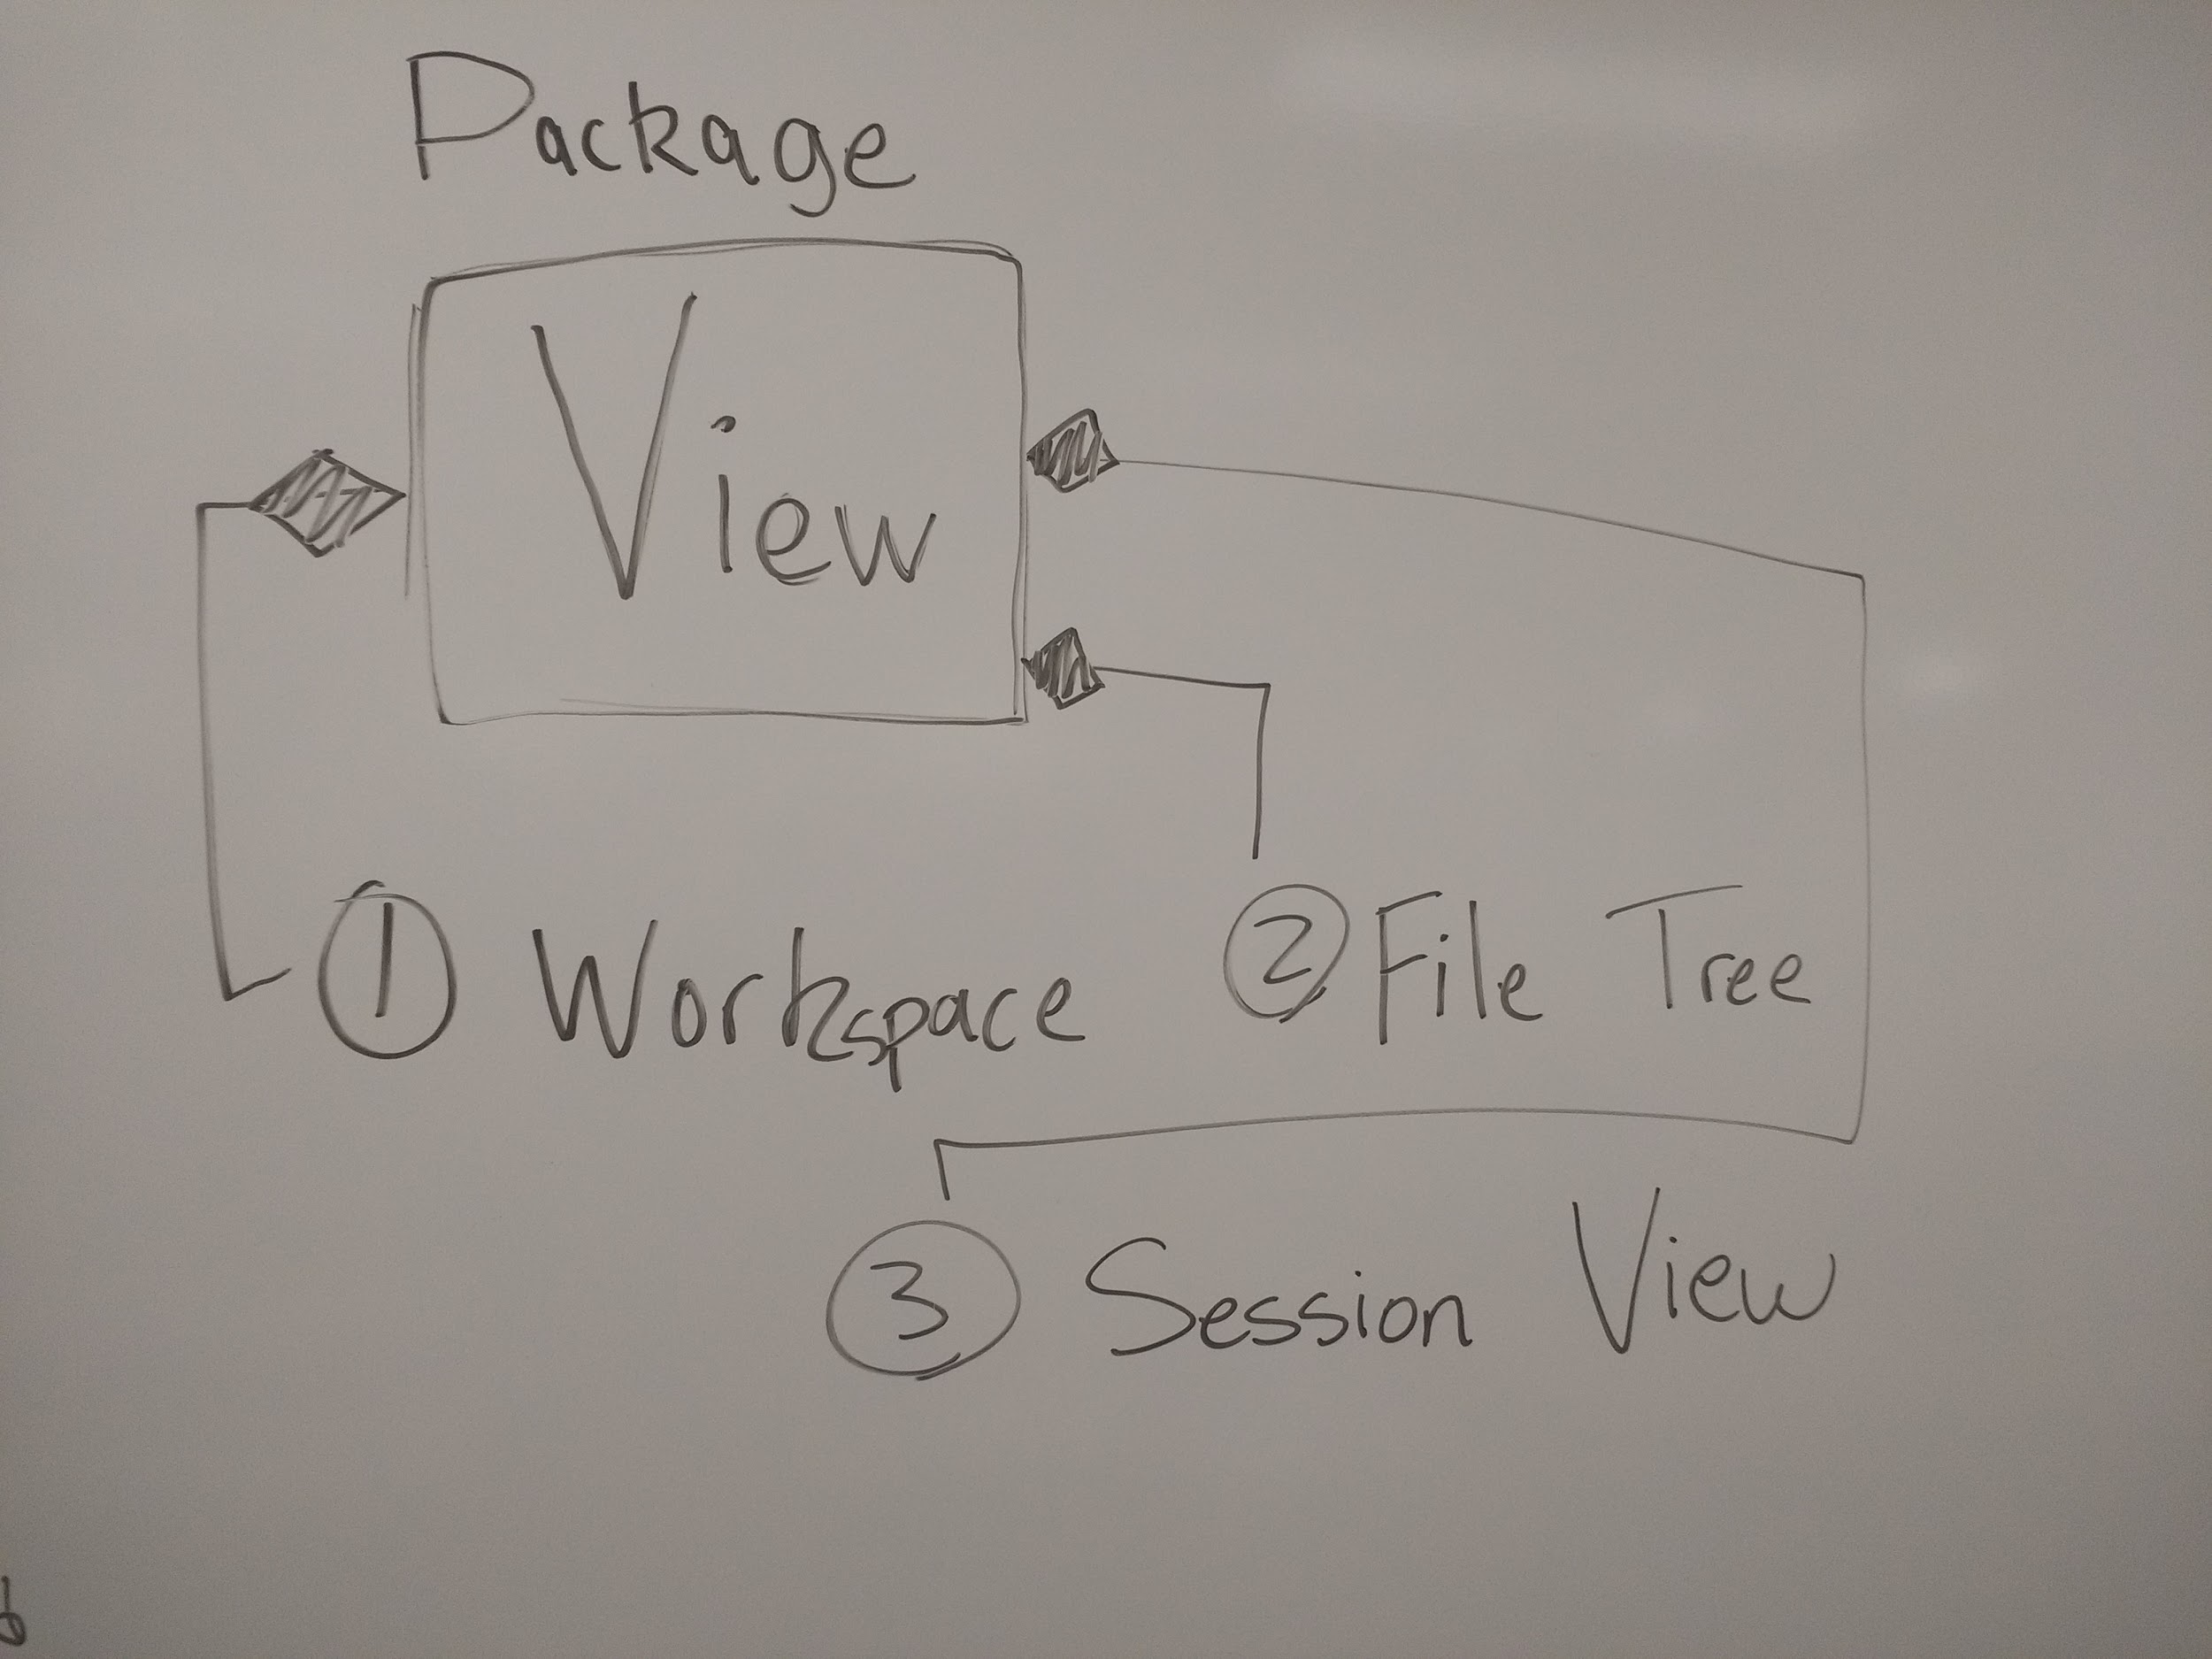
  + **Model**
    - 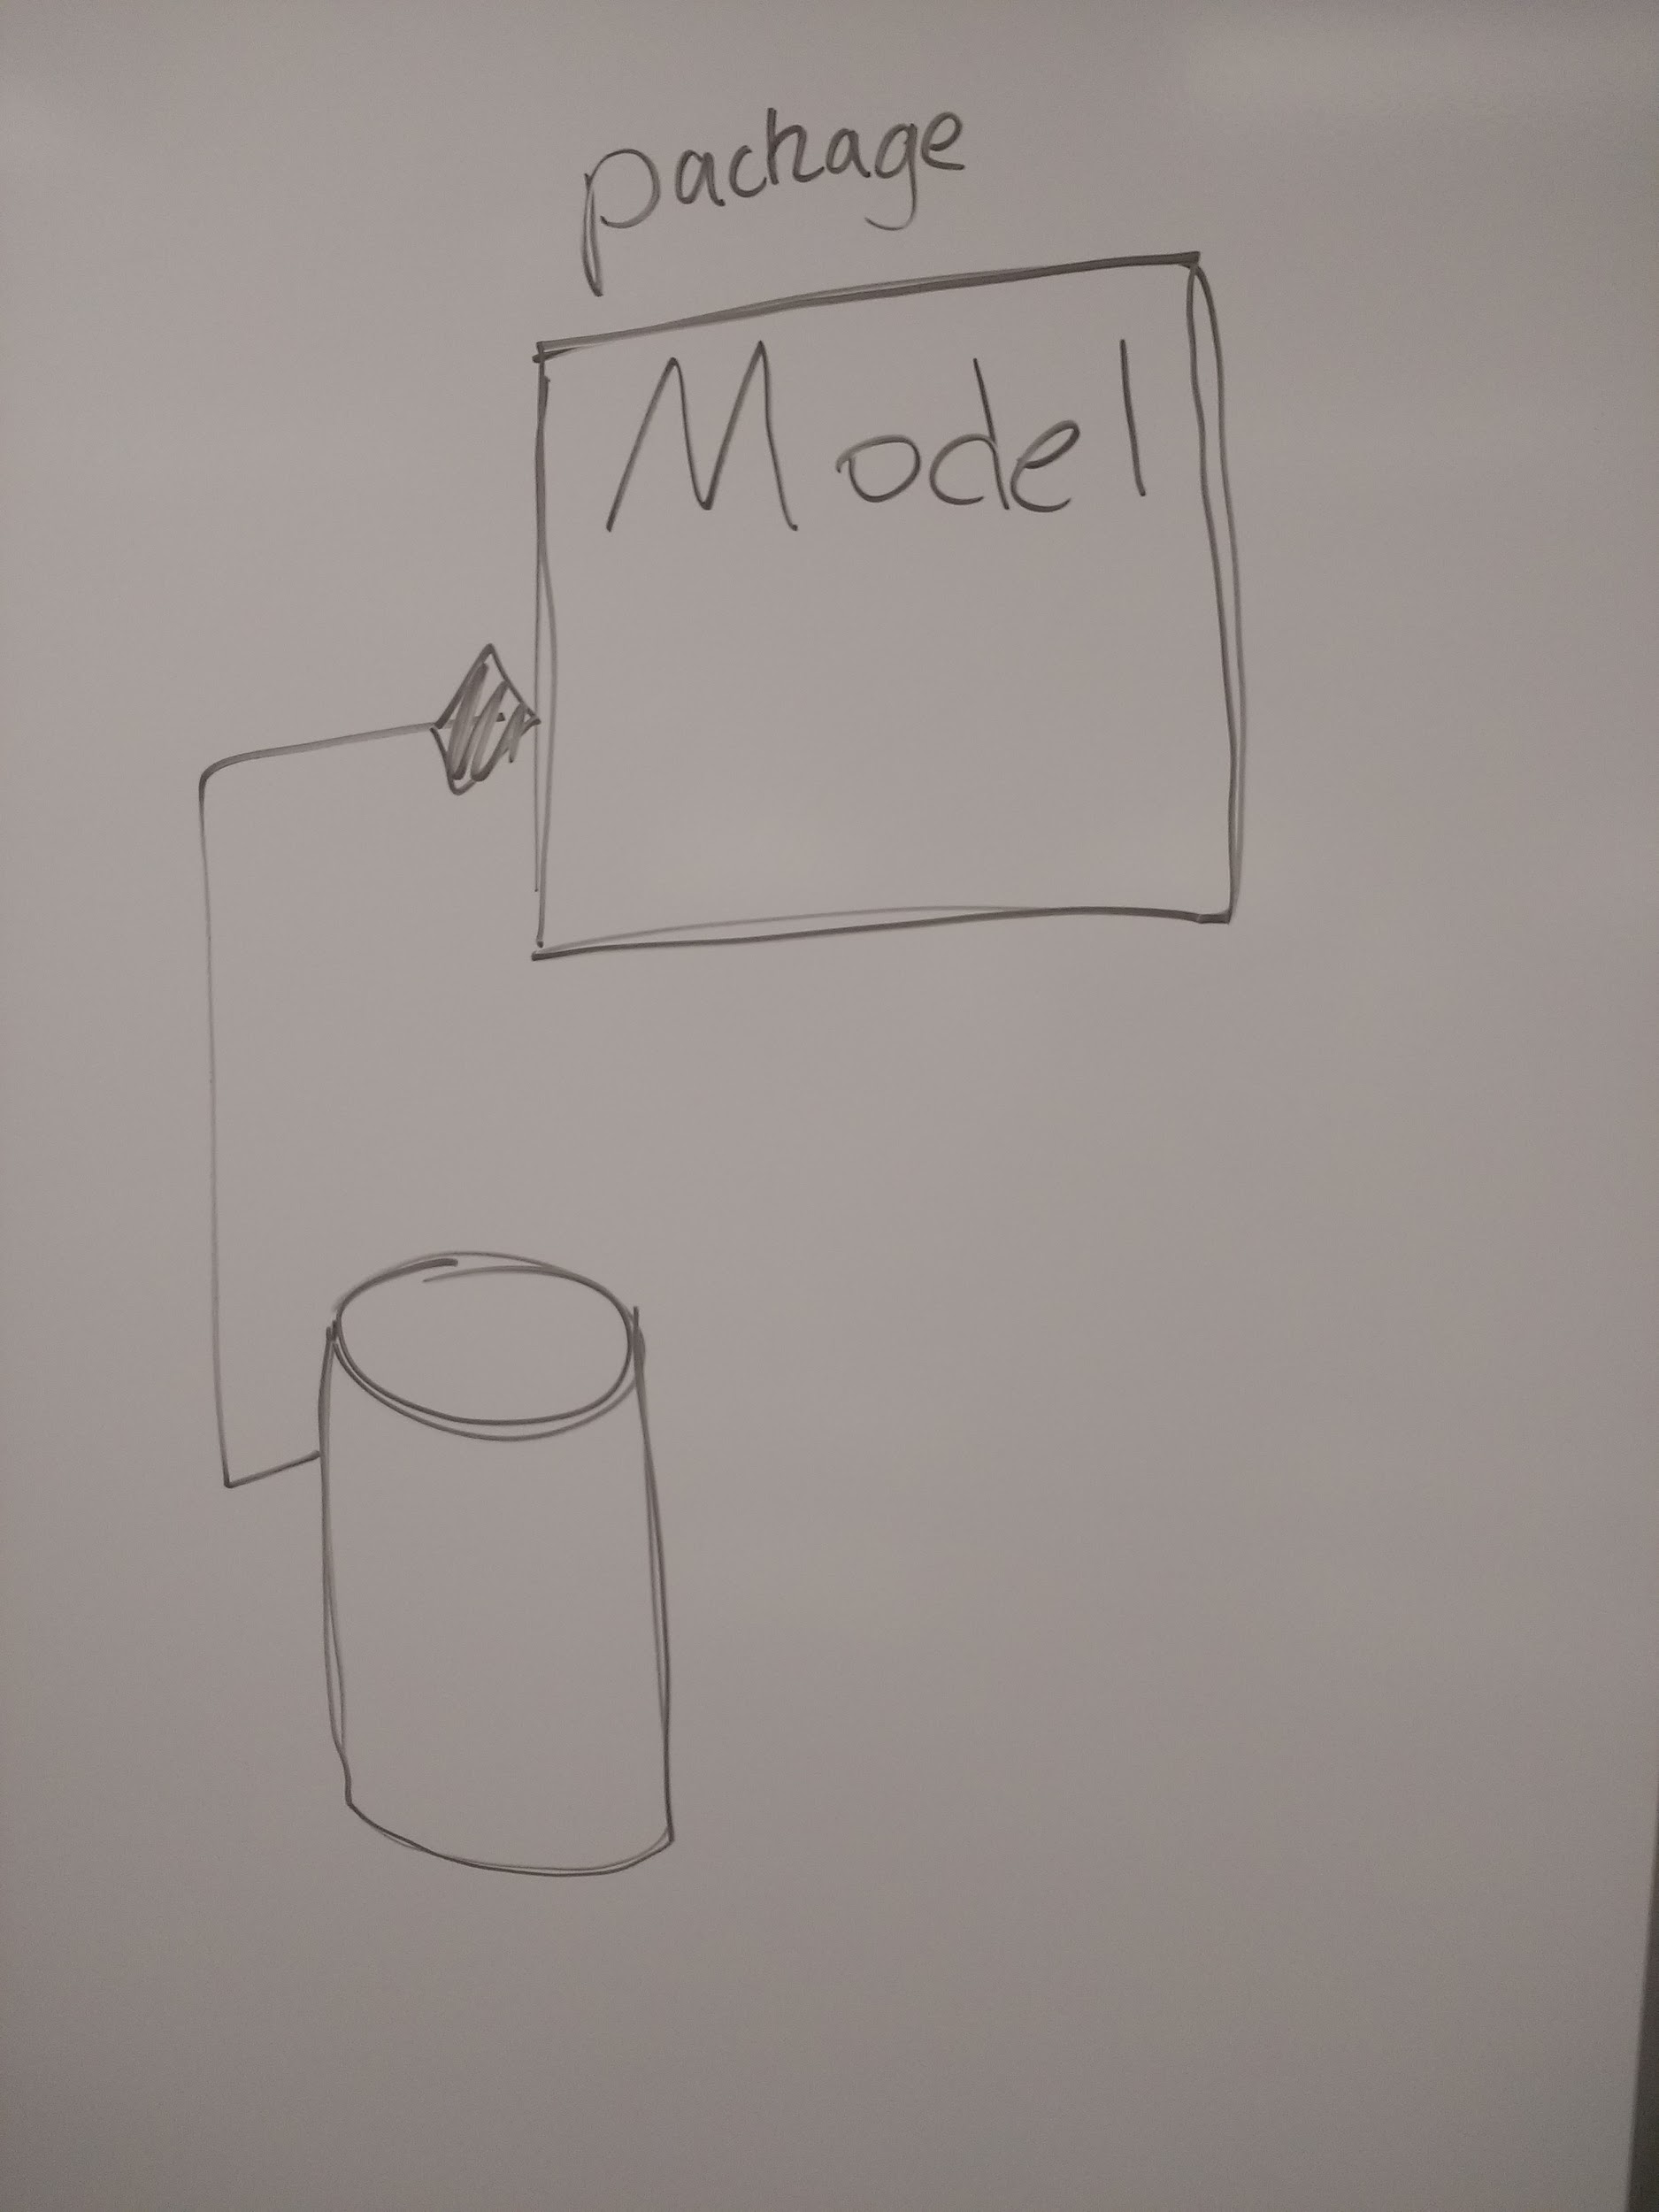
* Pure python example sent to Felix and Jeff -- Alex L
  + To test python execution
  + To test localhost port connection security concerns
* Class partitioning -- Anthony and Tony
  + Methods and signatures
  + Artifacts will be their own class
* **Grey Area with File Structure, Tagging System and Database documented**
  + 